JOUR 4251
Advertising and behavior change - Ch. 6 part 2
Theory of planned behavior
Behavioral
beliefs
Normative
beliefs
Efficacy beliefs
Attitude
Norms
Perceived behavioral control
Intention Behavior
Automatic behavior =
Processes that occur without intention, awareness, or effort
Explicit (conscious) vs. implicit (non-conscious) attitudes
Dual process theories would suggest that if you are MOTIVATED and ABLE, you are more likely to be influenced by conscious attitudes
Otherwise, more influenced by non-conscious / implicit attitudes Example: Branded vs. store-brand product
If you have time, you have time to THINK and you may say they are the same, just one is cheaper
If you are rushed, you will just grab the branded named one.
How are we primed in everyday life?
Christmas music in a store in December
Holiday mood? Implicitly remind you that you need to purchase gifts?

Christmas
music
Gifts
Christmas
Tree
Priming - associative network

Subliminal (priming) advertising
Messages below perceptual threshold: you don’t see them, but process them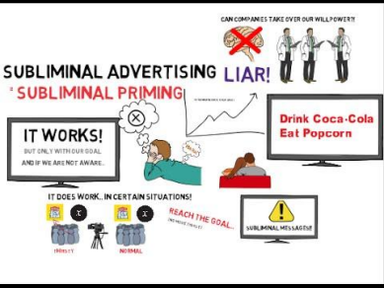

Automaticity - goals
Desired states
+ we haven’t reach it, but it is possible to reach
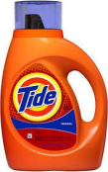
Goals are actions or outcomes towards which individuals hold positive attitudes.
Goals can be unconsciously activated and pursued
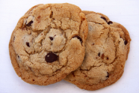
Automaticity - goals
Priming goals with brands
Example: Sports drink versus water study
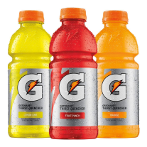
Goals, habits, and behaviors
Habits
Learned sequences of acts that have become automatic responses to specific cues and are functional in obtaining certain goals or end states
Something becomes a habit if performed frequently under stable conditions Example: Brushing your teeth
Goal dependent automaticity: you have to have the intention to do it, but then once you start, you just know how
Habits -brand loyalty
Intentions are a predictor of behavior.
However, for habitual behavior: past behavior is a better predictor of future behavior
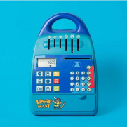
Brand loyalty is hard to change
Marketers:
We LIKE brand loyalty
We HATE it when trying to change behavior
Goal conflict and impulse behavior Goal conflicts: two or more goals conflict (example: diet + hedonic goal) Impulse buying: unplanned + without consideration
Often result of goal conflict rooted in a self-control dilemma Desire vs. willpower
How do you value goals?
You value the long-term goal less in the moment
Ego-depletion
What’s next?
● Start reading Chapter 7 (new chapter!)
○ Reading response #8 on this chapter is due April 2, 2:30 pm ● Assignment #4 on behavior is due by April 23, 2:30 pm

